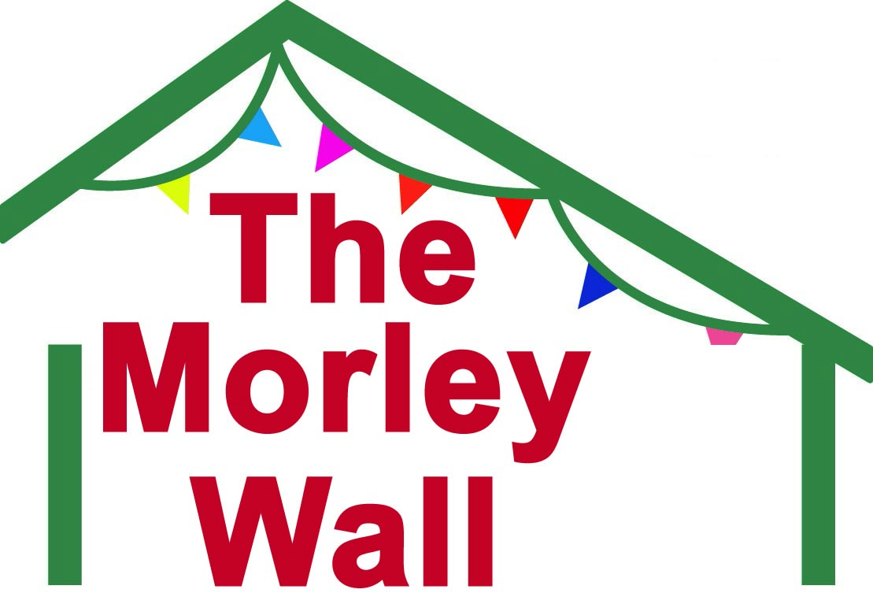 | MORLEY VILLAGE & SPORTS HALL  Terms & Conditions of use for Unsupervised Climbing at  THE MORLEY CLIMBING WALL

Participation Statement:
“All climbing and bouldering activities have a risk of serious injury or death. Participants must be aware of and accept that even if they follow all good practice there may still be the risk of accident and injury. It is the responsibility of the participant to adhere to the conditions of use below.”

Conditions of Use
General Safety
- Report to reception on each visit before you climb.
- You must exercise care, common sense and self-preservation at all times.
- Report any problems with the walls, equipment or other climbers' behaviour to a member of staff immediately. This is particularly important with broken or spinning holds.
- Be aware of the other climbers around you and how your actions will affect them.
- Do not distract people while they are climbing or belaying.
- Never stand directly underneath someone who is climbing.
- If you have children, you must keep them under control and supervise them directly at all times. Be close enough to affect or control the child’s behaviour at all times.
- Please make yourself aware of the location of the fire exits in the building and fire assembly points.

As a user of this climbing wall, you must be aware of and accept the following:
- Volumes on the walls are designed to enhance the quality of climbing but you must be aware of and accept that when climbing above them there is an additional risk of falling onto them.
- Climbing beyond your capabilities on any wall is likely to result in a fall. Any fall may result in an injury despite the safety systems in place. You must make your own assessment of the risks whenever you climb.
- Participants must understand that climbing while pregnant can increase the risk posed to mother and unborn child (we have a pregnant lady’s harness available if required).
- Participants must be aware and accept that climbing holds can spin or break.
- You must do everything reasonable and practical to avoid endangering yourself or others.
- Climbers and belayers should check each other’s knots and karabiners before each climb.
- Climbers should not start a climb, or start a descent, until the belayer has acknowledged they are ready and it is safe to do so.
- You have to be aware of and adhere to the safety rules of the centre at all times.
- Stand well back from the climbing walls unless you are belaying or spotting a climber.
- You take responsibility for adequately maintaining your equipment.
- Please empty your pockets and remove all jewellery before climbing.

Top Rope Climbing
- Always use a climbing harness to attach yourself to the rope tying the rope directly into the harness using a figure of 8 knot with a stopper, or a bowline knot with a stopper. Clipping in with a carabiner is not advised.
- All of the climbs in the centre have top ropes already in place. If you take them down or move them you must replace them, clipping the rope into both carabiners and ensuring the screwgate is tightened.
- It is your responsibility to vet your climbing partner's ability before they belay you.

Lead Climbing
- Lead belaying requires a higher degree of skill and understanding from top rope belaying and should only be undertaken if you have received training or are competent to do so. If you are unsure, do not climb and ask a staff member for available instruction at the centre.
- When lead climbing, you must supply your own appropriately rated dynamic rope.
- Quickdraws/runners/clips are provided on the wall. Please do not use your own.
- You must not skip clips and clips must be clipped in order.

When Belaying
- Always abide by good practice when belaying.
- Always use a belay device attached to your climbing harness with a locking carabiner as per manufacturers' guidelines. ‘Traditional’, or ‘body’, belaying is not acceptable.
- To ensure your partner's safety, pay attention to what the climber is doing.
- Always stand as close to the climbing wall as is practical, ensuring that if the climber falls, he/she will not fall onto you. Sitting or lying down is not acceptable.

Our Duty of Care
- The conditions of use of The Morley Wall are not intended to limit your enjoyment of the facilities; they are part of the duty of care that we, as operators, owe to you, our customer, by law. As such, they are not negotiable and if you are not prepared to abide by them then the staff may ask you to leave.

Your Duty of Care
- You have a duty of care to act responsibly towards the other users of the The Morley Wall, follow good practice and abide by the conditions of use of the centre.

Unsupervised Climbing
- Before you can use the top ropes or lead walls without supervision the The Morley Wall expects you to be competent in the use of a climbing harness, a suitable knot to attach a rope to the harness and a belay device to secure a falling climber or lower a climber from the wall using a rope.
- You are required to register to say that you know how to top rope or lead climb, that you are prepared to abide by the conditions of use of the centre and that you understand the risks involved in your participation. Anyone who is not competent to climb unsupervised must be supervised by a competent person.
- A practical assessment of your climbing ability and skills will be undertaken during your first few climbs.
- Novices or inexperienced climbers are not permitted to climb until they have undertaken a course given by a Climbing Instructor.

Signing in Guests
- Members can sign in one adult guest for a taster session. The guest will still be required to complete the Membership Process but will not be signed off as a competent climber.
- If a guest is a beginner, or not deemed competent to belay another climber, they may still climb at the taster session but must NOT belay anyone else unless under instruction. They may be required to attend a Training Course before they can register to climb unsupervised.
- Guest admission currently costs £6.00 per climbing session (this will be reviewed annually).
- Guests or novice climbers may ask for some training from our instructors for an additional £16 / session.

Exclusions
- Anyone younger than 14 years of age cannot become a Member of, or climb at, The Morley Wall. They must be with a qualified instructor.

BMC Membership (British Mountaineering Council)
Climbers are strongly recommended to be full or family members of The BMC as this gives you Personal Indemnity Insurance, as well as discounts to some outdoor shops.

GDPR
Your details, or any photos taken, will be used for marketing purposes in relation to Morley Village & Sports Hall and The Morley Climbing Wall (e.g. Promoting forthcoming events). Your details will not be passed on to third parties without your knowledge.

 | MORLEY VILLAGE & SPORTS HALL  Membership Form for Unsupervised Climbing at  THE MORLEY CLIMBING WALL | Membership Number
Personal Details (for handwritten forms, please complete using BLOCK CAPITALS)
Title |  |  | First Name |  |  |  |  |  |  |  | Last Name
Male / Female |  |  |  | Address
Date of Birth
Telephone
Mobile |  |  |  |  |  |  |  |  |  | Postcode
Email address
How did you hear about The Morley Wall?

Emergency contact
Please give name and contact details in the event of an emergency.

Name |  |  |  |  |  |  | Home telephone
Relationship to you |  |  |  |  |  |  | Mobile telephone

Conditions of Membership
Once you have read the “Conditions of Use” detailed above for The Morley Wall, you must answer the following questions by writing “YES” or “NO” in the box provided, or the number of years where asked, then sign and date the declaration at the bottom. Only climbers who give satisfactory answers to the following questions and demonstrate the necessary skills during the Unsupervised Climber Competency Assessment will be registered and allowed to climb unsupervised.
Are you between 18 & 80 years of age? If not, please give your age

If you are under 18 do you/your child take any medication or have any medical conditions that we should know about? If yes, please add brief details:
Do you understand that there is a risk of injury involved in climbing activities and that failure to exercise due care could result in your injury or death?
Have you read and understood the attached “Conditions of Use” of The Morley Wall for climbing?
(If you have any questions ask a member of staff)
Can you fit a climbing harness correctly, attach a rope to your harness using a suitable climbing knot and use a belay device to secure a falling climber and lower a climber from the wall?
Do you wish to receive any training or instruction before proceeding to use the climbing wall for Top Rope or Lead Climbing, including such equipment as has been hired or loaned to you for your use?
Do you agree to abide by this document and the conditions of use of the climbing centre?

Approximately how many years have you been climbing for?

Do you have any relevant qualifications? If so, please list or put “None”

Declarations and Acknowledgement of Risk for Climbers or Parents of Under 18’s

I certify that to the best of my knowledge, I do not suffer from a medical condition that might have the effect of making it more likely that I be involved in an accident that could result in injury to myself or others.
I also confirm that the above information is correct and if any information changes, I will notify the centre.

I HAVE HAD SUFFICIENT OPPORTUNITY TO READ THIS ENTIRE DOCUMENT. I HAVE READ AND UNDERSTOOD IT, AND I AGREE TO BE BOUND BY ITS TERMS.

It is important that you understand this document. There is inherent risk involved with climbing centres and associated activities. By signing this form, or by typing your full name, below you are stating you understand that these risks cannot be completely removed. If you do not understand any of the terminology or content, ask a member of staff to clarify. Typing your Name will act as an Electronic Signature.

Signature |  | Date

 | MORLEY VILLAGE & SPORTS HALL  Assessment for Unsupervised Climbing at  THE MORLEY CLIMBING WALL | Membership Number

 | THIS PART TO BE FILLED IN BY MORLEY VILLAGE HALL REPRESENTATIVE
 | Climber’s  Name |  |  |  |  | Date
 |  | Practical Assessment
 | Assessor’s Comments | Pass |  | Fail
 |  | Comments
 |  | Assessment Details
 | Assessor’s name |  |  |  |  | Assessor Qualification
 | Assessor’s Signature |  |  |  |  | Date

